

|  |
| --- |
| ITECH3208 – Project 1  Sprint 1 Performance, Progress and Outcomes  Submitted to : Nityansh Rattan |
| |  |  |  | | --- | --- | --- | | Group – 1 Harmanpreet Singh Bedi 30410228 Devansh Mahajan 30423978 Sahejdeep Singh 30418751 Aakash 30397890 | 9/15/24 |  | |

Table of Contents

Revision 3

Introduction 3

Sprint 1 3

Sprint Goals 3

Project Setup 3

Product Backlog 3

Prioritized User Stories 3

Sprint Backlog 4

Deliverables 7

Environment Setup 7

Project Management 7

Development Progress 7

Client Communication 7

Design and Data 8

Next Steps 8

Critical Revision 8

Outcomes of Sprint 1 9

# Revision

|  |  |  |  |  |
| --- | --- | --- | --- | --- |
| **Version** | **Date of revision** | **Team Members** | **Approved by** | **Brief Description** |
| 1.0 | 13/08/2024 | Harmanpreet Singh Bedi | Team Members and Client | The initial plan and sprint 1 is completed |
| Devansh Mahajan |
| Sahejdeep Singh |
| Aakash |

# Introduction

## Sprint 1

The objective of sprint 1 was to document the Project Scope, build mock-ups, and gain feedback on all of the completed tasks.

## Sprint Goals

Following are the goals of sprint 1 :

* Gather requirements and specifications from the client and document them.
* Create mock-ups by following the client’s specifications of the project.

# Project Setup

## Product Backlog

The product backlog decided (prior to the sprint) is :

* Requirement gathering and specifications
* Prototypes and mock-ups
* Front-end Development (html, css)
* Back-end Development (database creation and localhost server setup)
* Integration of Front-end with Back-end (fully dynamic website)

## Prioritized User Stories

From all of the above, these are the priority user stories that are must and needed to be completed prior to moving further into the project :

* Create a Project Scope so that all the requirements of the client can be identified.
* Arrange meetings with client and team members, retrospective meetings, daily standup meetings, etc.
* Create user stories on Jira and Create sub tasks to be done.
* Create some mock-ups for the Sprint - 1 so that client feedback can be gathered on initial requirements.
* Create Burn up and Burn down charts for Sprint – 1.

## Sprint Backlog

The prioritized sprints will create the Sprint Backlog for sprint 1. Here is the final sprint backlog:

* Sprint – 1
* Create a Project Scope so that all the requirements of the client can be identified.
* Arrange meetings with client and team members, retrospective meetings, daily standup meetings, etc.
* Create user stories on Jira and Create sub tasks to be done.
* Create some mock-ups for the Sprint - 1 so that client feedback can be gathered on initial requirements.
* Create Burn up and Burn down charts for Sprint – 1.

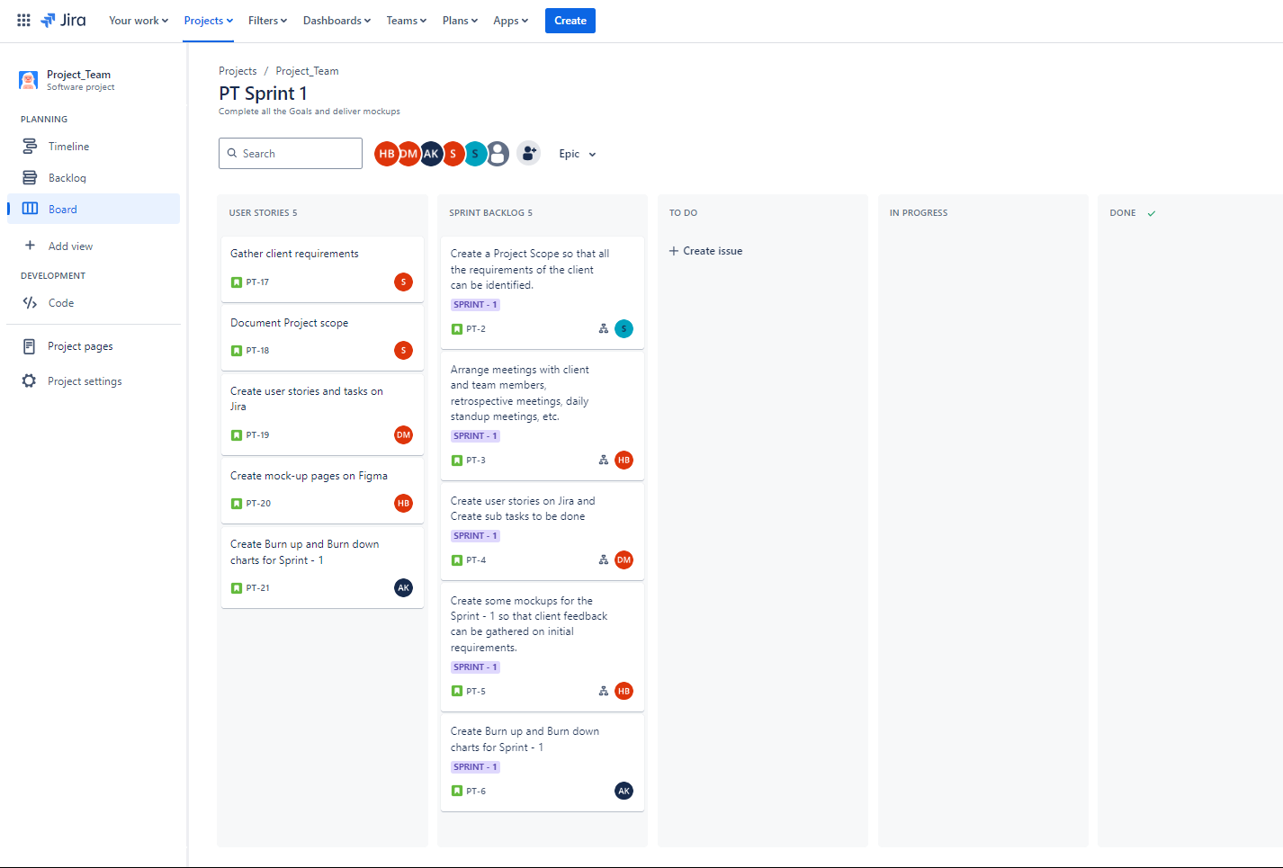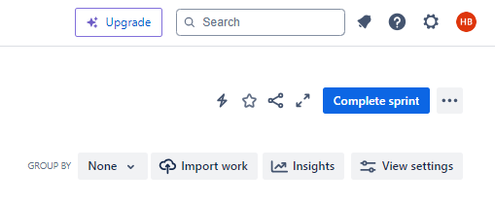

Figure 1. Sprint backlog and User stories for Sprint – 1

Figure 2. To-Do user stories

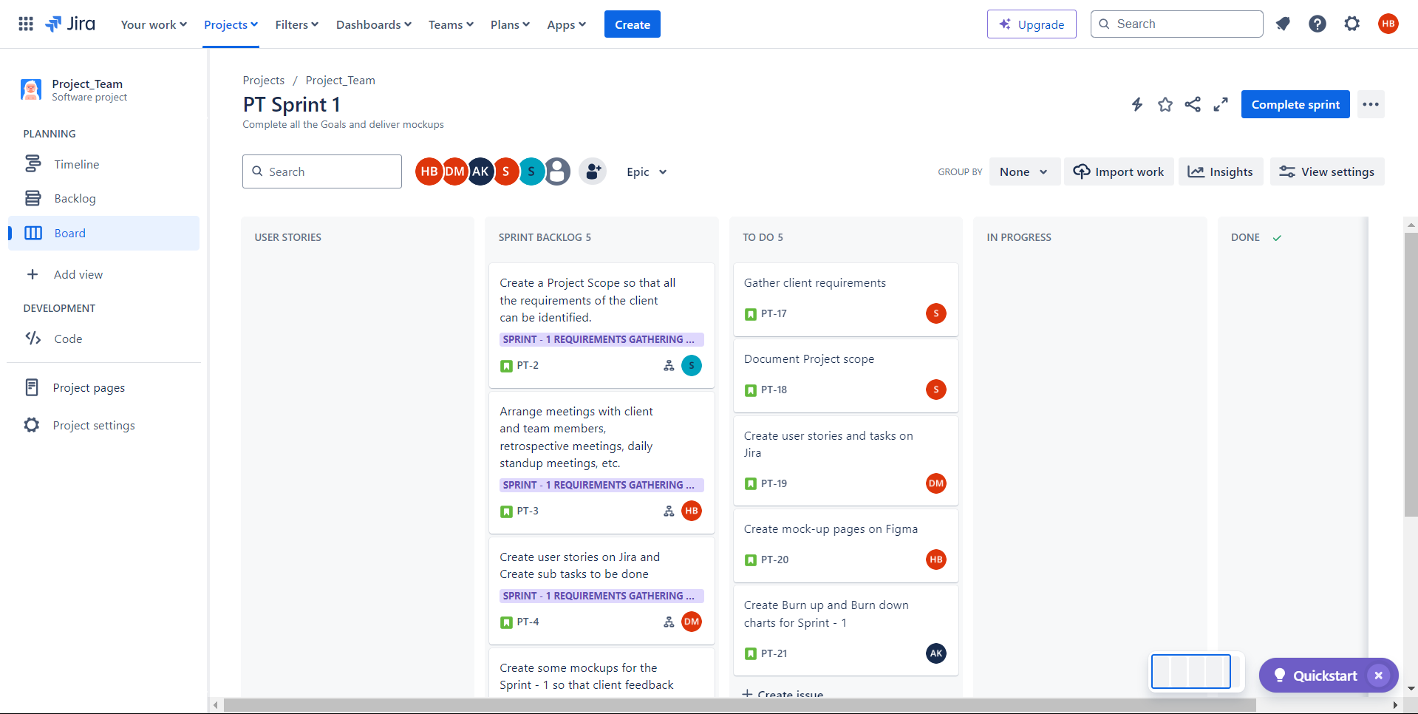

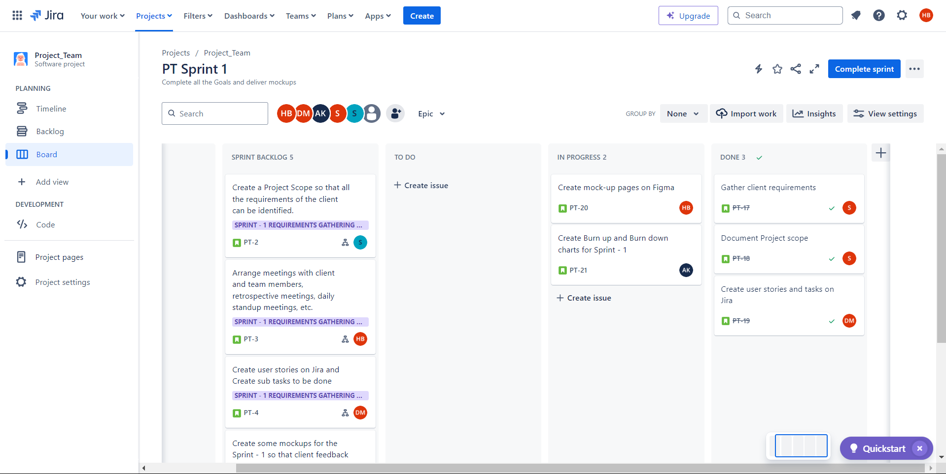

Figure 3. In-Progress and Done user stories

Figure 4. In-Progress and Done user stories

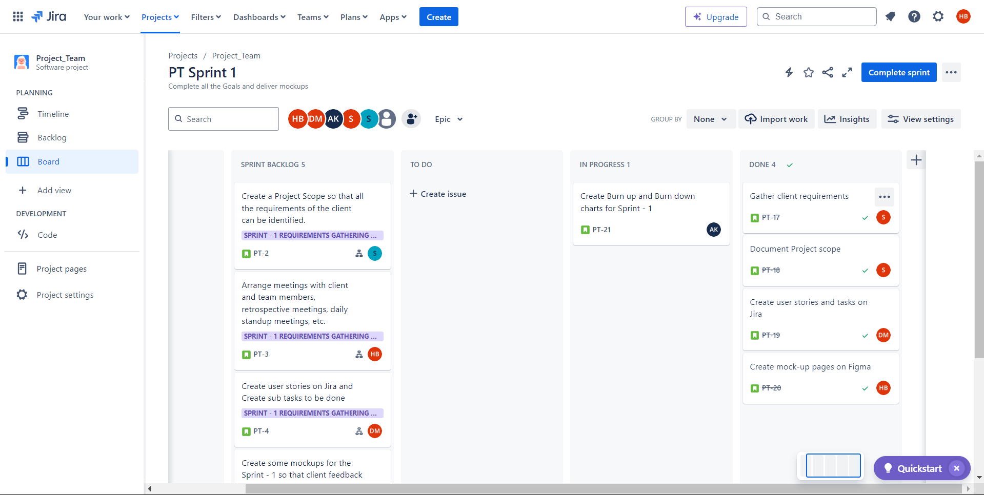

Figure 5. User stories Timeline

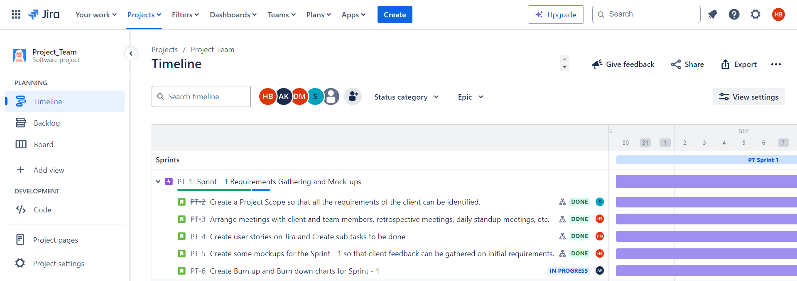

|  |  |
| --- | --- |
| **PBIs (Product Backlog Items)** | **Assignees** |
| Project Scope | Sahejdeep Singh |
| User stories and Tasks | Devansh Mahajan |
| Mock-up pages | Harmanpreet Singh Bedi |
| Burn up and Burn down charts | Aakash |

Table 1. Sprint backlog provided indicating PBIs

# Deliverables

## Environment Setup

All the working environment that are required for the project are configured and setup. Software used :

* Documentation : Microsoft Word
* Tracking Sprint Progress : Jira Board (Timeline and Backlog)
* Mockups and Prototypes : Figma
* Coding : Visual Studio Code
* Local backend server : XAMPP
* Testing : Web Browsers like Google Chrome, Edge and Firefox
* Meetings : Microsoft Teams

## Project Management

Jira is used efficiently for project management. It defines user stories, tasks and sprint backlog along with To-Do, In Progress, and Done lists to define tasks and track progress.

## Development Progress

In this sprint, the project team successfully documented the requirements, created Project Scope and created mock-ups of Login, Home and Products page.

## Client Communication

Client feedback meeting was held while the project was in early stages of development. This helped us to gain an early insight about the team’s progress track and gather feedback on that.

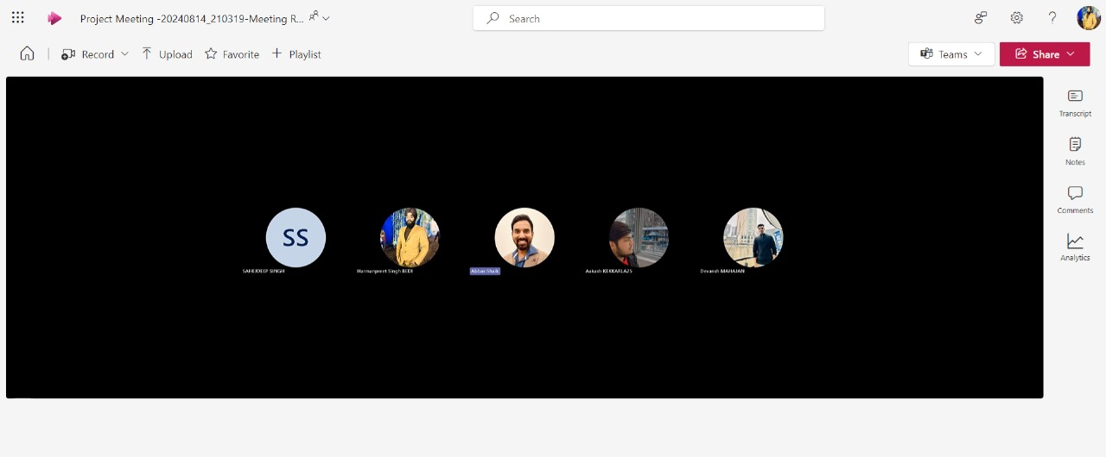

Figure 6. Client feedback meeting in early stages of development

## Design and Data

When the mock-ups were created and ready, that provided a visual roadmap about the project. Although only three pages were ready, we were able to visualize client’s requirements and project development.

## Next Steps

The next steps will contribute towards completion of sprint – 2. It will include building prototypes and mock-ups for all the portals and complete website.

# Critical Revision

A backlog refining meeting was conducted and following is the refined product backlog with set priorities :

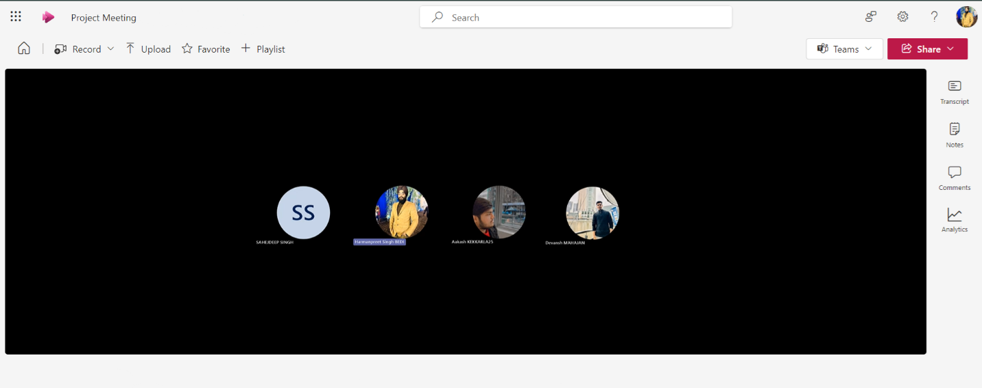

Figure 7. Backlog refining meeting

|  |  |
| --- | --- |
| **PBIs** | **Priority** |
| Requirement gathering and specifications   * Gather client requirements * Document the specifications * Create user stories and tasks * Create burn up and burn down charts * Start creating mock-ups | * High * High * High * High * Medium |
| Prototypes and mock-ups   * Review client requirements * Create prototypes * Create mock-ups * Edit changes provided by client’s feedback | * High * High * High * Medium |
| Front-end Development (html, css)   * Setup VS Code, XAMPP and other tools. * Write the code while reviewing the branding theme and specifications (through mock-ups). * Create user portal * Search products * View products * Filter products * Add to cart * Checkout process * Create admin portal * Create products * Edit products * Delete products * Create employees * Edit employees * Delete employees * Inventory Management (stock levels) * Create employee portal * View products * View users * View stocks | * High * High * High * High * High * High * High * High * Medium * High * High * Medium * High * High * High * High * High |
| Back-end Development (database creation and localhost server setup) | High |
| Integration of Front-end with Back-end (fully dynamic website) | High |

# Outcomes of Sprint 1

Goals were identified and deliverables are of high quality, and are according to the client’s requirements.

1. Project scope :

The project scope was made only after finalizing all the specific details and specifications, and noting down the requirements that they need for their project.

These requirements were reviewed repeatedly while documenting project scope to ensure we meet each and every requirement of the client.

After all these, a scope was finalized and a feedback meeting with a client was arranged. The client was satisfied with the scope and told us to move forward with the project.



Figure 8. Client feedback meeting

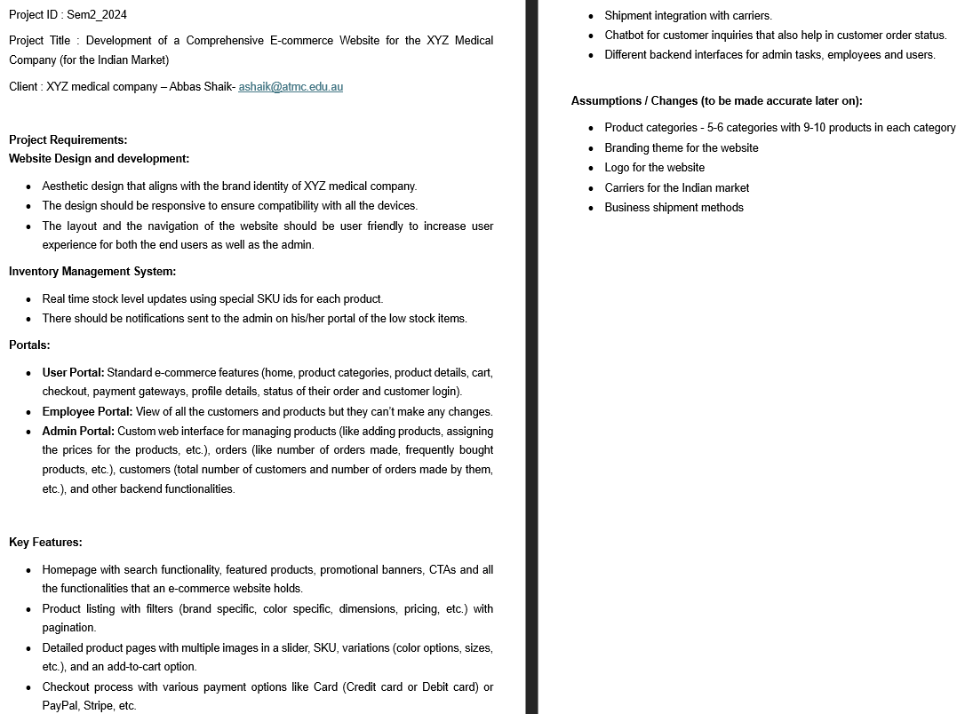

Figure 8. Finalized project scope

1. Mock-up pages :

Three mock-up pages were created : Login, Home and Products

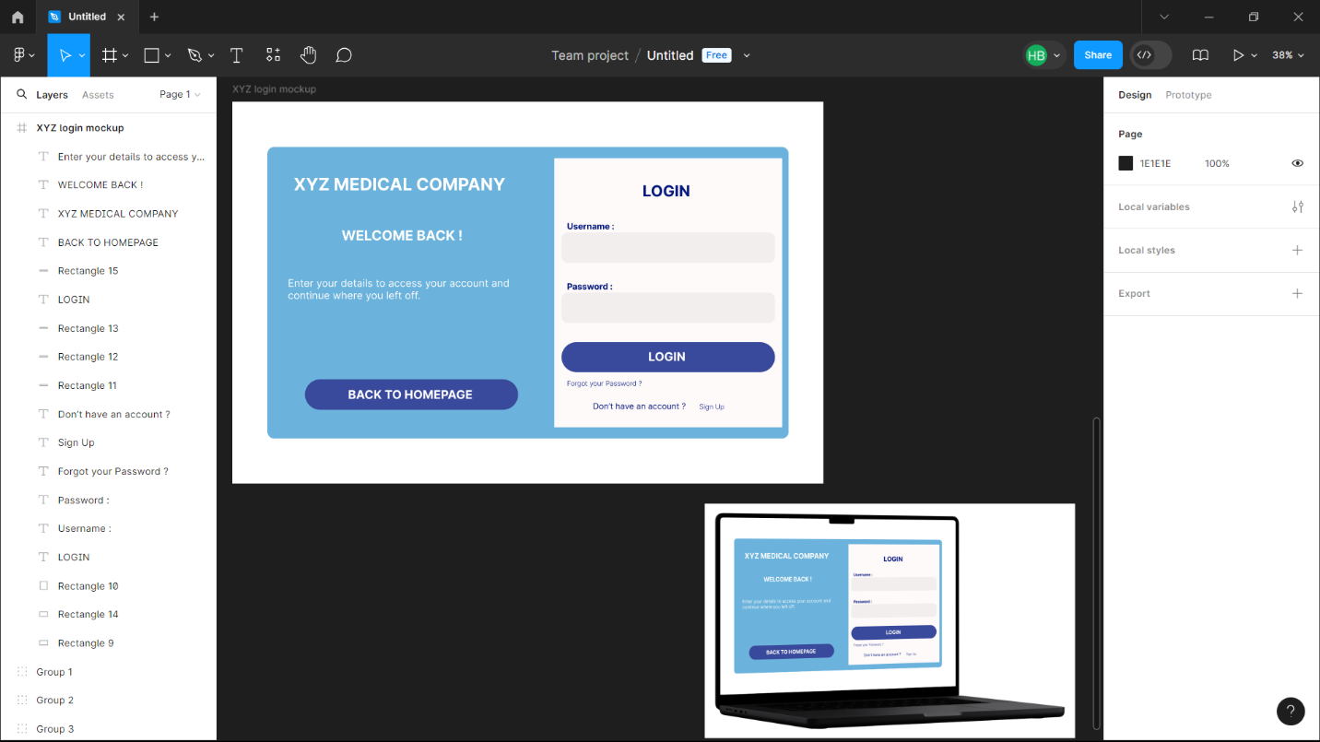

Figure 9. Login mock-up

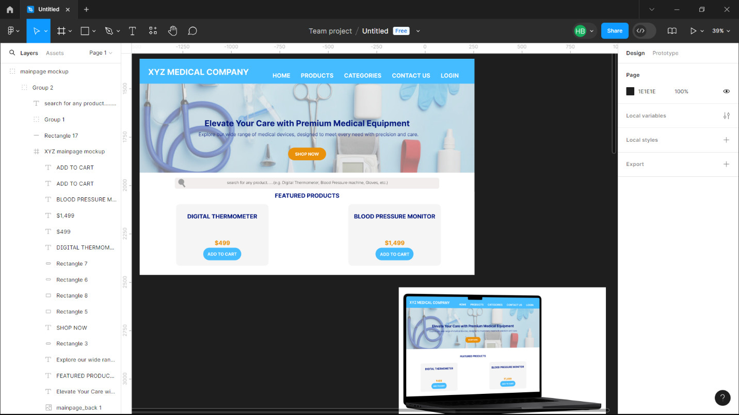

Figure 10. Home page mock-up

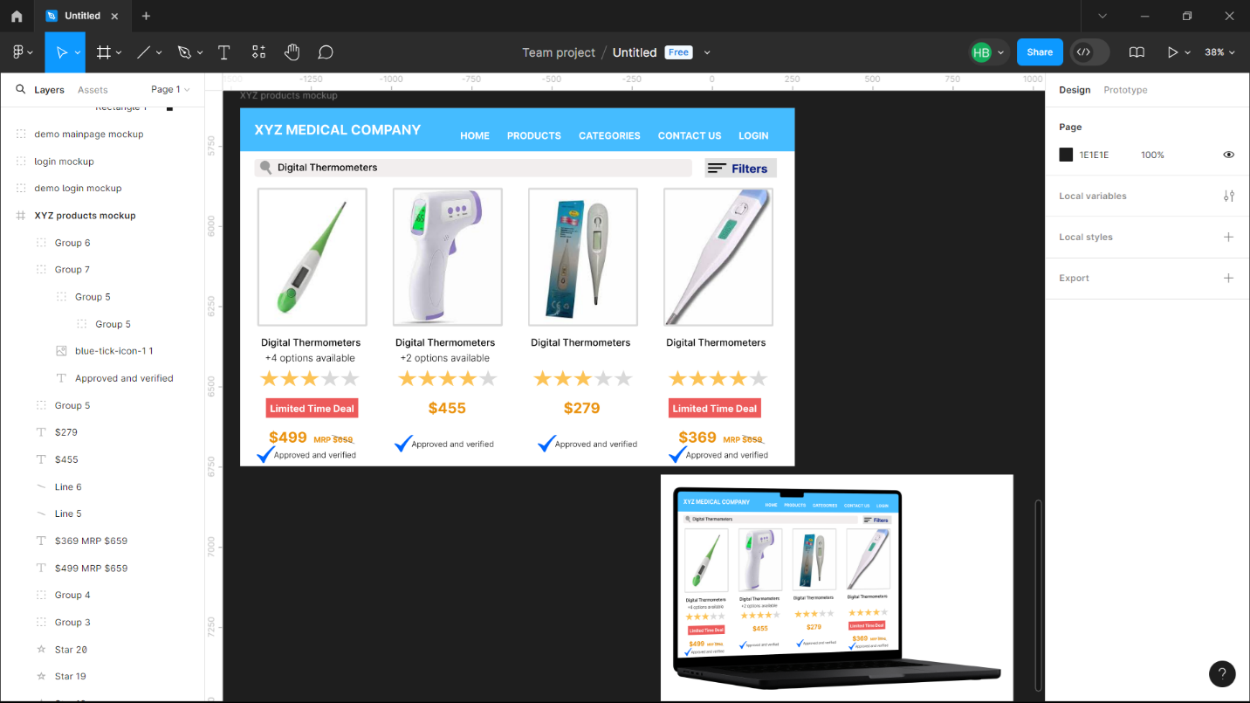

Figure 11. Products mock-up

1. Jira Board



Figure 12. Sprint backlog and User stories for Sprint – 1

Figure 13. To-Do user stories





Figure 14. In-Progress and Done user stories

Figure 15. In-Progress and Done user stories



Figure 16. User stories Timeline



1. Meetings

Client Feedback meeting



Sprint end retrospective meeting



In the retrospective meeting, we did some question analysis :

* What I did ?
* What are the remaining tasks ?, and
* What challenges I faced in my tasks ?

Every member was encouraged to give answers to these questions :

|  |  |
| --- | --- |
| **Questions** | **Answers of members** |
| What I did ? | Harmanpreet Singh Bedi : I arranged all the meetings during the sprint, and made mock-up pages once the scope was finalized by the client. |
| Devansh Mahajan : I was responsible for making user stories and tasks on Jira board that could be later assigned to every member. |
| Sahejdeep Singh : I documented all the requirements of the client into a Project Scope, along with helping my team member Harman with mock-ups. |
| Aakash : I am making burn up and burn down charts for the user stories that are on the Jira Board. |
| What are the remaining tasks ? | Harmanpreet Singh Bedi : As of now, no remaining tasks are left. |
| Devansh Mahajan : No remaining tasks. However, optimization can be done of the product and sprint backlog. |
| Sahejdeep Singh : No remaining tasks left. |
| Aakash : Charts are still pending. |
| What challenges I faced in my tasks ? | Harmanpreet Singh Bedi : The major challenge was to gather all the team members for meetings as everyone was having their own schedule. |
| Devansh Mahajan : No such challenge faced. |
| Sahejdeep Singh : I was new to Figma so it took a little bit of time to get familiar with it. |
| Aakash : No challenge. |

Link to our Jira board : https://itech3208.atlassian.net/jira/software/projects/PT/boards/2